StudyPulse: Development of a Mobile-Based Student Performance Tracker with Built-in Reviewer and Quiz System for Third Year BSIT Students



MEMBERS:
BALDADO, JOLAN M.
BALDADO, JOYCE ANN S.
BONDOC, NICA JOY T.
TADEO, PAULA MARIE B.

MARCH 2026
TABLE OF CONTENTS

Title Page……………………………………………………………………………………………1

Table of Contents…………………………………………………………………………………..2

Chapter 1 – Introduction…………………………………………………………………………..4
The Problem and it’s Background…………………………………………………………….4
Review of related Literature………………………………………………………………….. 7
Conceptual Framework…………………………………………………………………….….14
Statement of the Problem……………………………………………………………………..16
Scope and Delimitation…………………………………………………………………….…17
Significant of The Problem…………………………………………………………………..20
Definition of Terms…………………………………………………………………………..21
Chapter 2 – Methods And Procedures……………………………………………………………23
Research Design………………………………………………………………………………23
Locale of The Study………………………………………………………………………….24
Respondents of the Study…………………………………………………………………….25
Sample and Sampling Procedure…………………………………………………………….27
Research Instrument………………………………………………………………………….28
Data Gathering Procedure……………………………………………………………………34
Data Analysis Technique ……………………………………………………………………35
Ethical Consideration…………………………………………………………………………36
Reference………………………………………………………………………………………….38

Appendices………………………………………………………………………………………… 40

APPENDIX A Letter of Request…………………………………………………………………..41
APPENDIX B IT Expert Survey Questionnaire …………………………………………………..43
APPENDIX C End User Survey Questionnaire ……………………………………………………49
APPENDIX D Curriculum Vitae……………………………………………………………………56

CHAPTER 1
INTRODUCTION
THE PROBLEM AND IT’S BACKGROUND
‎ In today’s digital era, mobile technology plays a crucial role in education, reshaping how students access learning resources, monitor their progress, and assess their academic performance. Third-year BSIT students face increasing academic demands, creating a need for an efficient and easily accessible system to support their studies. Traditional methods of tracking grades and reviewing lessons are often manual, time-consuming, and susceptible to disorganization, which can negatively impact productivity and performance. To address these challenges, mobile-based learning applications are being developed to offer a more structured, interactive, and convenient educational experience. A system that combines performance tracking with built-in reviewers and quizzes can help students identify their strengths and weaknesses, develop better study habits, and ultimately improve their overall academic outcomes.
With the continuous advancement of mobile technology, students are increasingly relying on smartphones as tools for learning. In higher education institutions, particularly in Information Technology programs, students are required to manage multiple subjects, projects, quizzes, and examinations. However, many students struggle to monitor their academic performance effectively due to the lack of a centralized system that combines performance tracking and review materials. To address this concern, this study proposes the development of StudyPulse, a mobile-based student performance tracker integrated with a built-in reviewer and quiz system. This application is specifically designed for Third Year Bachelor of Science in Information Technology (BSIT) students to help them monitor their academic progress, assess their strengths and weaknesses, and enhance their review experience through interactive quizzes. By integrating performance tracking and review functionalities into one mobile platform, StudyPulse aims to provide a more organized, accessible, and efficient way for students to manage their academic responsibilities.
Despite the growing use of mobile applications in education, there remains a significant gap in systems specifically designed to address the combined needs of performance tracking and structured review for Third Year BSIT students. Many existing academic applications focus solely on either grade monitoring or quiz-based learning, but rarely integrate both features into a single, centralized mobile platform tailored to a specific academic program. As a result, students often rely on multiple separate tools—such as manual grade lists, social media group notes, or generic quiz applications—which may lead to disorganization, inefficiency, and difficulty in monitoring overall academic progress.
Furthermore, most available student tracking systems are not customized to align with the curriculum and academic requirements of BSIT programs, particularly at the third-year level where coursework becomes more specialized and technically demanding. There is a lack of a dedicated mobile-based system that not only tracks academic performance in real time but also provides built-in review materials and interactive quizzes aligned with students’ subjects.
At Nueva Ecija University of Science and Technology (NEUST) – Talavera Off-Campus, this gap is evident among Third Year BSIT students who do not have access to a centralized and integrated mobile-based platform for both performance monitoring and structured review. Consequently, students experience challenges in organizing their academic tasks and effectively tracking their learning progress.
In addition, in today’s digital environment where mobile device usage is widespread, many students struggle to manage their time effectively. A significant portion of their mobile usage is often spent on non-academic activities, which can negatively affect their productivity and focus. This situation further highlights the need for a system that can guide students in managing their study time while supporting their academic development.
To address these issues, this study proposes the development of StudyPulse: A Mobile-Based Student Performance Tracker with Built-in Reviewer and Quiz System for Third Year BSIT Students. The proposed system aims to integrate performance monitoring and structured review into a single, accessible, and user-friendly mobile application. It will also incorporate interactive features such as badges and level progression to enhance student engagement, motivation, and overall learning experience, while helping them improve time management and effectively track their academic development.
The study aims to create a user-friendly and accessible mobile application that allows students to efficiently monitor and track their academic performance in different subjects. The system will integrate course modules provided by professors, ensuring that the learning materials available in the application are aligned with the actual lessons and course requirements. In addition, the application will include a built-in reviewer that organizes study materials in a structured format to support students in their preparation for quizzes, examinations, and other academic activities.
Furthermore, the study intends to design and implement an interactive quiz system that enables students to assess their understanding, measure knowledge retention, and evaluate their learning progress. To further encourage student engagement and motivation, the application will incorporate gamification features such as badges and levels, which reward students for completing quizzes, achieving high scores, and consistently reviewing study materials.
Through real-time performance monitoring, the application will help students identify their strengths and areas that require improvement. The system is expected to promote better study habits, improve time management, and enhance the overall academic performance of students. Additionally, the effectiveness, usability, and reliability of the StudyPulse application will be evaluated among Third Year BSIT students to ensure its functionality, practicality, and relevance in supporting their academic learning.
REVIEW RELATED LITERATURE
Mobile Learning and Gamification in Student Academic Performance
The use of mobile learning and gamification in education has been widely studied because of its potential to improve student engagement and academic performance. ‎
‎According to Pechenkina et al. (2017), gamified mobile applications can increase student engagement, retention, and academic achievement by incorporating quizzes and game elements such as badges and leaderboards. Their study showed that students who used mobile learning tools performed better compared to those who used traditional learning methods. ‎
‎Similarly, Hwang and Chang (2016) found that game-based mobile learning environments improve students’ motivation and learning performance. Their research emphasized that mobile applications allow students to access learning materials anytime and anywhere, making learning more flexible and interactive. ‎
‎Meanwhile, Inettutor (2023) discussed that mobile-based reviewer applications help students prepare for examinations by providing review materials, quizzes, and progress tracking features that support independent learning. ‎ ‎
In addition, López-Belmonte et al. (2022) examined the impact of mobile applications on students’ learning success in accounting education. Their findings revealed that students who actively used mobile learning applications achieved better academic performance compared to those who relied only on traditional methods. The researchers explained that mobile applications provide accessible learning resources, practice activities, and immediate feedback, which help improve students’ understanding and retention of lessons. ‎ ‎
Furthermore, Jivet et al. (2026) explored how students engage with mobile study applications and how this engagement affects their learning performance. The study showed that students who frequently interacted with mobile learning tools demonstrated higher levels of engagement and stronger self-regulated learning skills. Features such as progress tracking, feedback systems, and regular practice activities encourage students to become more responsible for managing their own learning process. ‎
Mobile Learning Systems and Academic Performance Enhancement
‎Based on these studies, the proposed system StudyPulse integrates mobile learning, quiz systems, performance tracking, and gamification features such as tracking, badges, levels, and rewards. The system aims to provide an interactive platform where students can review materials, take quizzes, and monitor their academic progress while instructors manage learning resources and quizzes. ‎ ‎ ‎
According to Pechenkina et al. (2017), gamified mobile learning applications can significantly increase student engagement, retention, and academic achievement. Their study introduced a mobile learning application that delivered quizzes directly to students’ mobile devices. The results showed that students who frequently used the application performed better academically and demonstrated higher engagement compared to students who relied only on traditional classroom methods. The integration of gamification elements such as badges, leaderboards, and progress indicators helped motivate students to participate more actively in learning activities.
Similarly, Garzón et al. (2025) conducted a meta-analysis of several studies on mobile learning and found that mobile learning environments significantly improve student learning outcomes. Their research showed that mobile learning tools allow students to engage in active and student-centered learning experiences. Because students can easily access educational resources through their mobile devices, they are more likely to review lessons, practice exercises, and participate in learning activities even outside the classroom.
In addition, Pedraja-Rejas et al. (2024) examined the relationship between mobile learning and students’ learning outcomes through a systematic review of various academic studies. The researchers found that integrating mobile learning applications into educational environments can improve academic performance as well as students’ critical thinking skills. Mobile learning platforms encourage independent learning by allowing students to explore learning materials and practice exercises at their own pace, which strengthens knowledge retention and understanding.
Furthermore, Anselmo et al. (2024) investigated the effectiveness of mobile learning tools in improving student engagement and learning outcomes. Their study revealed that interactive educational technologies such as mobile learning systems, digital educational tools, and learning applications can significantly enhance students’ motivation and conceptual understanding. These technologies help students develop deeper learning experiences by combining instructional content with interactive activities such as quizzes, exercises, and digital assessments.
Meanwhile, Sung, Chang, and Liu (2016) studied the effects of integrating mobile devices in teaching and learning environments. Their research found that the use of mobile learning systems enables students to access course materials, assessments, and learning resources conveniently through their mobile devices. The study concluded that students who actively used mobile learning platforms demonstrated improved academic performance, increased participation, and greater engagement in their courses compared to those who relied only on traditional learning methods.
Mobile-Based Academic Support Systems and Gamification in Learning
Based on these studies, the proposed system StudyPulse: Development of a Mobile-Based Student Performance Tracker with Built-in Reviewer and Quiz System for Third Year BSIT Students integrates mobile learning technology with features such as review materials, quizzes, and student performance tracking. The system is designed to provide an accessible and interactive platform where students can review lessons, assess their understanding through quizzes, and monitor their academic progress. By combining these features into a single mobile application, StudyPulse aims to support students in improving their academic performance and enhancing their overall learning experience.
Mobile-based academic support systems have become an important tool in helping students monitor and improve their academic performance. Many educational institutions are now integrating mobile technologies in order to provide students with convenient access to learning resources and assessment tools. These systems allow students to track their learning progress, review lessons, and evaluate their understanding through interactive activities.
According to Kim, Park, and Baek (2019), mobile learning applications that include quiz-based assessments can significantly improve students’ knowledge retention and learning outcomes. Their study found that frequent exposure to short quizzes through mobile platforms encourages students to practice regularly and strengthens their understanding of academic topics. The researchers emphasized that quiz systems integrated into mobile applications can help students identify their strengths and weaknesses in different subject areas.
Another study conducted by Alrasheedi, Capretz, and Raza (2015) examined the factors that influence the adoption of mobile learning systems in higher education. Their findings revealed that students prefer mobile learning platforms because of their convenience, accessibility, and ability to support self-directed learning. The researchers concluded that mobile applications that combine learning materials, assessments, and progress monitoring features can enhance students’ learning experiences and academic engagement.
Furthermore, Al-Emran, Mezhuyev, and Kamaludin (2018) investigated the effectiveness of mobile learning systems in higher education environments. Their research showed that mobile-based educational systems allow students to learn more independently by providing easy access to course materials, quizzes, and learning resources.
Similarly, Dichev and Dicheva (2017) examined the role of gamification in educational systems and found that incorporating elements such as badges, points, and levels can increase students’ motivation and engagement in learning activities. Their study emphasized that gamified learning environments encourage students to participate more actively and improve their academic performance through continuous interaction with learning tasks.
Effects of Mobile Learning on Study Habits and Academic Performance
The study also highlighted that mobile learning technologies encourage students to take a more active role in their education, which leads to improved academic performance and better learning outcomes.
The use of mobile learning technologies in education has transformed students’ study habits and academic performance by providing accessible learning resources and flexible study methods. Mobile learning apps allow students to interact with educational content anytime and anywhere, promoting more active and self-directed learning. These technologies have been widely explored in recent research, especially in relation to student engagement and academic achievement.
According to Hattie, Sahlberg, and Comer (2023), mobile learning apps have significant impacts on students’ study habits and academic performance by increasing access to learning materials and facilitating changes in how students interact with course content. Their review showed that mobile apps can enhance students’ note-taking practices, reading strategies, and interaction with course materials, which in turn can affect academic indicators such as grades and retention rates. However, the study also noted potential challenges such as digital distractions and reduced face-to-face interaction that can influence learning outcomes.
Similarly, Abrahams (2024) found that mobile learning applications in online education settings enhance engagement and personalized learning experiences. His review indicated that students using educational apps demonstrate higher levels of participation, better interaction with learning resources, and improved academic performance compared to traditional methods. This suggests that mobile learning apps not only provide content access but also support flexible and responsive learning environments. Studies outside review articles also support these findings.
Klimova (2019) reported that university students who used mobile learning applications for language learning had significantly higher performance compared to those who did not use such apps. This highlights the ability of mobile learning tools to improve academic achievement when integrated effectively into learning processes. Further supporting the positive effects of mobile technology on students, research by MDPI shows that student use of mobile technology for academic purposes positively influences engagement and higher-order thinking skills, which are linked to improved learning outcomes. However, it also notes that poorly designed use or distractions from technology can hinder performance. On the other hand, some research points out limitations of mobile device use in academic settings. For example, a study on digital device usage among undergraduate students found no significant difference in performance when devices were used during lectures, suggesting that simply having access to mobile technology does not guarantee academic improvement.
SYNTHESIS
The reviewed literature consistently indicates that mobile learning technologies and gamification positively influence student engagement, motivation, and academic performance. Mobile-based applications provide flexible and convenient access to educational materials, quizzes, and assessment tools, enabling students to study anytime and anywhere. Features such as interactive quizzes, gamification elements, and digital progress monitoring promote active participation and strengthen understanding of academic concepts.
Research further suggests that mobile learning enhances personalized learning experiences and supports higher-order cognitive skills. Studies in specific academic domains, such as language learning, demonstrate measurable improvements in learning outcomes when mobile applications are used intentionally. However, the effectiveness of these technologies is contingent upon thoughtful instructional design and purposeful integration; mere usage of devices without targeted academic application may not yield significant benefits.
Despite these advantages, many existing mobile learning systems focus on isolated features, such as quizzes or gamified activities, rather than providing a comprehensive platform that combines multiple academic support tools. This gap highlights the need for integrated solutions that not only deliver content but also track performance and provide engaging, interactive experiences. In response, the proposed StudyPulse system seeks to integrate review materials, quizzes, performance tracking, and gamification in a single mobile-based platform, thereby fostering independent learning, improving study habits, and enhancing overall academic performance for Third Year BSIT students.
CONCEPTUAL FRAMEWORK
This study is anchored on the Input–Process–Output (IPO) Model, which illustrates how the proposed system, StudyPulse, transforms collected data into meaningful outputs that support student performance monitoring and academic improvement. The model explains the relationship among the inputs provided by the users, the processes performed by the system, and the outputs generated after the data has been processed.
As shown in Figure 1, the conceptual framework presents the flow of the system using the Input–Process–Output structure.
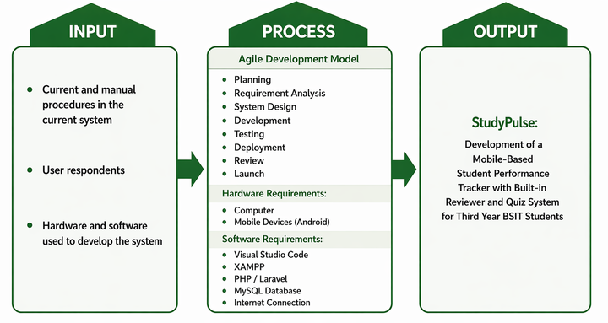
Figure 1 Conceptual Framework of the Study
The Input represents the initial elements required for the development of the system. This includes the problems encountered by third year BSIT students in monitoring their academic performance and their need for an organized digital reviewer and quiz system. It also includes the hardware requirements such as a computer, Android mobile device, and internet connection that are necessary to run and access the system. Additionally, the software requirements consist of development tools including Visual Studio Code, XAMPP, PHP/Laravel, and MySQL database. Study materials and quiz content are also included as inputs since they serve as the learning resources integrated into the system.
The Process represents the procedures used in developing the StudyPulse system. The study follows the Agile Development Model, which allows iterative and flexible system development. The process begins with planning, where the project objectives and scope are identified. This is followed by requirement analysis, where the needs of the users are determined. Next is system design, where the structure and interface of the system are planned. The development phase involves coding and building the application using the selected tools such as Visual Studio Code, XAMPP, PHP/Laravel, and MySQL. After development, the system undergoes testing to ensure that the features function properly. The system is then deployed, reviewed, and finally launched for user utilization.
The Output of the framework is the developed system called StudyPulse, a mobile-based student performance tracker with a built-in reviewer and quiz system specifically designed for third year BSIT students. The system aims to help students monitor their academic progress, access review materials, and assess their knowledge through quizzes in an organized and convenient digital platform.

STATEMENT OF THE PROBLEM
This study generally aims to develop and evaluate StudyPulse: Development of a Mobile-Based Student Performance Tracker with Built-in Reviewer and Quiz System for Third Year BSIT Students. In evaluating the developed system, the study adopts the ISO/IEC 25002 standard as a basis for measuring software quality through defined quality measures and evaluation criteria. Specifically, this study seeks to answer the following questions:
1.1 security of files and records;
1.2 management of data;
1.3 reliability of output;
1.4 efficiency of processes; and
1.5 compliance with regulations and standards?
2. How may the developed system be described in terms of software development phases using Agile Model?
2.1 planning and requirements gathering;
2.2 design and prototyping;
2.3 development and implementation; and
2.4 testing and deployment?
3. How may the IT consultants evaluate the developed StudyPulse: Development of a Mobile-Based Student Performance Tracker with Built-in Reviewer and Quiz System for Third Year BSIT Students in terms of the following software characteristics using ISO 25002:
3.1 functional suitability;
3.2 performance efficiency;
3.3 compatibility;
3.4 usability; and
3.5 security?
4. How may the end-users evaluate the developed application based on the System Usability
Scale (SUS) in terms of the following usability characteristics using ISO 25002:
4.1 ease of use;
4.2 efficiency;
4.3 learnability; and
4.4 user satisfaction?
SCOPE AND DELIMITATIONS
This study focuses on the development of StudyPulse, a mobile-based student performance tracker with a built-in reviewer and quiz system for third-year BSIT students. The system allows students to review learning materials, take quizzes, and monitor their academic performance. Instructors can upload learning resources and create quizzes, while a super administrator manages system settings and user accounts. The application also integrates gamification features such as badges, levels, and rewards to increase student engagement.
The system operates on Android mobile devices and is developed using specific software and hardware tools. The software tools used in the development include Visual Studio Code as the code editor, PHP with Laravel Framework for backend development, MySQL as the database management system, and XAMPP as the local server environment. An internet connection is also required for system access and data synchronization.
In terms of hardware, the development and testing of the system require a computer or laptop and an Android mobile device for deployment and user testing.
This study is limited to third-year BSIT students and instructors and does not cover other year levels or programs. The system is designed exclusively for Android platforms and does not support iOS devices.
The system is limited to third-year BSIT students and instructors involved with their classes and is not applicable to other programs or year levels. It does not include video conferencing, chat, or other communication features, and it is not directly connected to official school grading systems. The application operates exclusively on mobile platforms, with no full desktop version included. The evaluation of the system is limited to usability, functionality, and performance tracking efficiency, and the study does not measure long-term academic performance outcomes.
This study utilizes the Agile Software Development Model as the primary framework for developing StudyPulse. Agile was chosen for its focus on flexibility, continuous improvement, and collaboration among developers, which are essential for creating a functional and user-centered mobile application. Through an iterative and incremental process, the development team designs, builds, tests, and refines the system in small cycles or sprints. This approach allows for regular feedback from users, particularly third-year BSIT students, ensuring that the application meets their academic needs and expectations. Agile also facilitates faster problem identification and resolution, enabling continuous enhancement of system features such as performance tracking, reviewer integration, and quiz functionality. By applying this model, StudyPulse is developed efficiently, systematically, and with continuous user involvement, resulting in a reliable and effective mobile-based educational tool.
The respondents of this study will consist of four (4) IT experts who will evaluate the system in terms of functionality, reliability, and technical quality. The end-users of the system will include ten (10) instructors and three hundred twenty (320) third-year BSIT students from sections 3A to 3H, with forty (40) students in each section. These end-users will evaluate the StudyPulse mobile application based on its usability, accessibility, and effectiveness. In total, the study involves three hundred thirty (330) respondents.
The case study will be conducted at Nueva Ecija University of Science and Technology (NEUST) Talavera Off-Campus, focusing primarily on Third Year Bachelor of Science in Information Technology (BSIT) students who will serve as the primary users and respondents of the proposed system. This location was selected because the researchers aim to address the academic monitoring and review needs of BSIT students within the institution, particularly those experiencing challenges in tracking their academic progress and organizing their study materials.
The case study will be conducted during the current academic semester of School Year 2026–2027 to ensure that the data gathered is timely, relevant, and reflective of the students’ present academic situation. Conducting the study within this semester allows researchers to assess students’ actual performance, needs, and challenges in their respective subjects. This timeframe also provides sufficient opportunity for data collection, analysis, and interpretation, ensuring that the study’s outcomes are reliable and beneficial to both current and future batches of students.

SIGNIFICANCE OF THE STUDY
The researchers conduct this study with the aim of providing crucial information and knowledge regarding the StudyPulse: Development of a Mobile-Based Student Performance Tracker with Built-in Reviewer and Quiz System for Third Year BSIT Students. Therefore, this study will benefit the following:
Students - StudyPulse provides third-year BSIT students with a convenient tool to monitor their academic performance in real-time. By integrating a built-in reviewer and quiz system, students can identify their strengths and weaknesses, improve their learning habits, and enhance their preparedness for examinations. This promotes self-directed learning and fosters academic responsibility.
Teachers and Academic Advisers - The system allows instructors and academic advisers to monitor students’ progress efficiently. With access to performance data and quiz results, they can provide targeted guidance and interventions for students who may need additional support, thereby improving teaching effectiveness and student outcomes.
Future Researchers and Developers - This study serves as a foundation for future enhancements in mobile-based learning systems. Researchers and developers can build upon StudyPulse to include advanced features, such as analytics dashboards, gamified learning, or integration with other educational platforms, fostering innovation in educational technology.
Educational Institutions - For the school or university, StudyPulse contributes to improving the overall quality of education by offering a data-driven approach to student performance tracking. This can inform curriculum adjustments, resource allocation, and the design of learning activities that align with students’ needs.
‎DEFINITION OF TERMS
Gamification ‎- The application of game design elements such as points, badges, leaderboards, and rewards in non-game environments to increase user engagement, motivation, and participation in learning activities.
‎Mobile Learning Application ‎- A software program designed to run on mobile devices such as smartphones or tablets that allows users to access educational content, perform learning activities, and monitor academic progress. ‎
‎Student Performance Tracking ‎- A system or process that records, monitors, and evaluates students’ academic progress through collected data such as quiz scores, subject performance, and overall learning outcomes. ‎
StudyPulse ‎- The proposed mobile application developed in this study that integrates a reviewer, quiz system, and performance tracking features to help third-year BSIT students monitor and improve their academic progress. ‎ ‎
End Users – In this study, end users refer to the people who will use the system after it is developed. They interact with the system to perform tasks and evaluate whether it is effective and user-friendly. ‎
IT Experts – In this study, IT experts refer to the professionals or individuals with technical knowledge who evaluated the system. They assessed the system’s functionality, reliability, and overall technical quality.
ISO 25002 - An international standard within the SQuaRE (Systems and Software Quality Requirements and Evaluation) series that provides a framework for defining, structuring, and using quality models
Variables of IT Experts - A combination of technical competencies, professional experience, education, and soft skills needed to manage, maintain, and secure an organization's technology infrastructure.
Chapter 2
METHODS AND PROCEDURES
This chapter includes the method of the research used, research locale, subject populations, instruments used, the gathering of the data and statistical devices utilized for the treatment of data.
RESEARCH DESIGN
This study utilized a developmental research design as it aimed to develop and evaluate a mobile-based application called StudyPulse: A Mobile-Based Student Performance Tracker with Built-in Reviewer and Quiz System for Third Year BSIT Students. Developmental research focuses on the systematic design, development, and evaluation of systems or applications intended to solve identified problems and improve existing processes. ‎
‎In this study, the developmental approach was appropriate because the researchers designed and developed a mobile application that integrates performance tracking, reviewer materials, quiz systems, and gamification features. The study followed a structured process of system development using the Agile Model, which includes planning, requirement analysis, system design, development, testing, and deployment. ‎
‎The research also involved the evaluation of the developed system in terms of usability, functionality, and performance efficiency. IT experts assessed the technical quality of the application based on ISO 25002 software characteristics, while end-users, particularly third-year BSIT students, evaluated the system using the System Usability Scale (SUS). This ensured that the application is not only functional but also user-friendly and effective in supporting students’ academic needs. ‎
‎Furthermore, the developmental research design allowed continuous improvement of the system through feedback gathered during the testing phase. This iterative process ensured that the StudyPulse application meets the required standards and provides an efficient, accessible, and interactive platform for students to monitor their academic performance, review lessons, and enhance their learning experience.
LOCALE OF THE STUDY
The study will be conducted at Nueva Ecija University of Science and Technology – Talavera Off-Campus, located in Pag-asa Talavera Nueva Ecija. The institution is a public university that offers various undergraduate programs, including the Bachelor of Science in Information Technology (BSIT), which focuses on developing students’ technical skills and knowledge in computing and information systems.

It started as the Wright Institute in 1908, became the Nueva Ecija Trade School in 1929, was renamed the Central Luzon School of Arts and Trades in 1953 and the Central Luzon Polytechnic College in 1964 before being converted into NEUST in 1998. The Talavera campus is one of the satellite campuses (or academic extension venues) operated by NEUST in the province, addressing localized higher education needs. The campus supports specialized fields such as Teacher Education (Elementary), BS in Information Technology (Web System & Database Systems), and BS in Business Administration (Marketing Management).

Figure 2 : Nueva Ecija University of Science and Technology, Talavera Off-Campus
RESPONDENTS OF THE STUDY
This study involved a total of 336 respondents to evaluate the developed system, StudyPulse: Development of a Mobile-Based Student Performance Tracker with Built-in Reviewer and Quiz System for Third Year BSIT Students, in terms of software quality characteristics based on the ISO/IEC 25002 Software Product Quality Standards.
Out of the total respondents, four were IT experts who evaluated the system in terms of its technical quality and compliance with software standards. The remaining respondents were classified as end-users, consisting of one Head Admin, one Admin, ten instructors, and three hundred twenty third-year BSIT students.
The Head Admin and Admin assessed the system in terms of administrative control, data management, and monitoring capabilities. The instructors evaluated its effectiveness as a teaching and performance tracking tool, while the students assessed its usability, functionality, and overall user experience.
The responses gathered from these participants served as the basis for determining whether the developed system meets the required software quality standards and is appropriate for its intended users.
The following table, Table 1, shows the distribution of the respondents:

Table 1
Distribution of Respondents
Distribution of Respondents | Number of Respondents
Expert Sampling | 4
End-User Statistical Sampling  -Instructor  -Third-Year BSIT Students  3A  3B  3C  3D  3E  3F  3G  3H | 10  40  40  40  40  40  40  40  40
Total | 330

SAMPLE AND SAMPLING PROCEDURE
Based on the table of respondent distribution, this study involved a total of 330 respondents composed of 4 experts, 10 instructors, and 320 third-year BSIT students from eight sections (3A–3H), with 40 students from each section.
The study used a combination of expert sampling and stratified sampling. Expert sampling was applied in selecting the four (4) experts based on their knowledge, experience, and relevance to the field of the study. These experts were included to evaluate and validate the system.
For the end-users, stratified sampling was employed. The third-year BSIT students were grouped according to their respective sections (3A, 3B, 3C, 3D, 3E, 3F, 3G, and 3H), which served as the strata. From each section, forty (40) students were included to ensure equal representation and to minimize sampling bias. In addition, ten (10) instructors were included as respondents because they are directly involved in the instructional process and are considered actual users of the system. This sampling approach ensured balanced representation from experts, instructors, and student end-users, contributing to the reliability and validity of the study.
RESEARCH INSTRUMENT
In order for the developed StudyPulse: Development of a Mobile-Based Student Performance Tracker with Built-in Reviewer and Quiz System for Third Year BSIT Students to be assessed, the researchers used the ISO/IEC 25002 standard. The ISO/IEC 25002 standard is part of the ISO/IEC 25000 series, which focuses on software product quality evaluation. This standard provides guidelines and characteristics that are used to assess the quality of software systems.
The ISO/IEC 25002 is composed of different quality characteristics that relate to both the functional and non-functional aspects of a software product. These characteristics include functional suitability, performance efficiency, compatibility, usability, and security, which are essential in evaluating the overall performance and reliability of the system. These are applicable to both software products and computer systems in various environments of use.
In addition, the model also considers user-centered characteristics such as ease of use, efficiency, learnability, and user satisfaction, which focus on the user’s interaction and overall experience when using the system. These characteristics are important in determining how effectively and efficiently users can utilize the application.
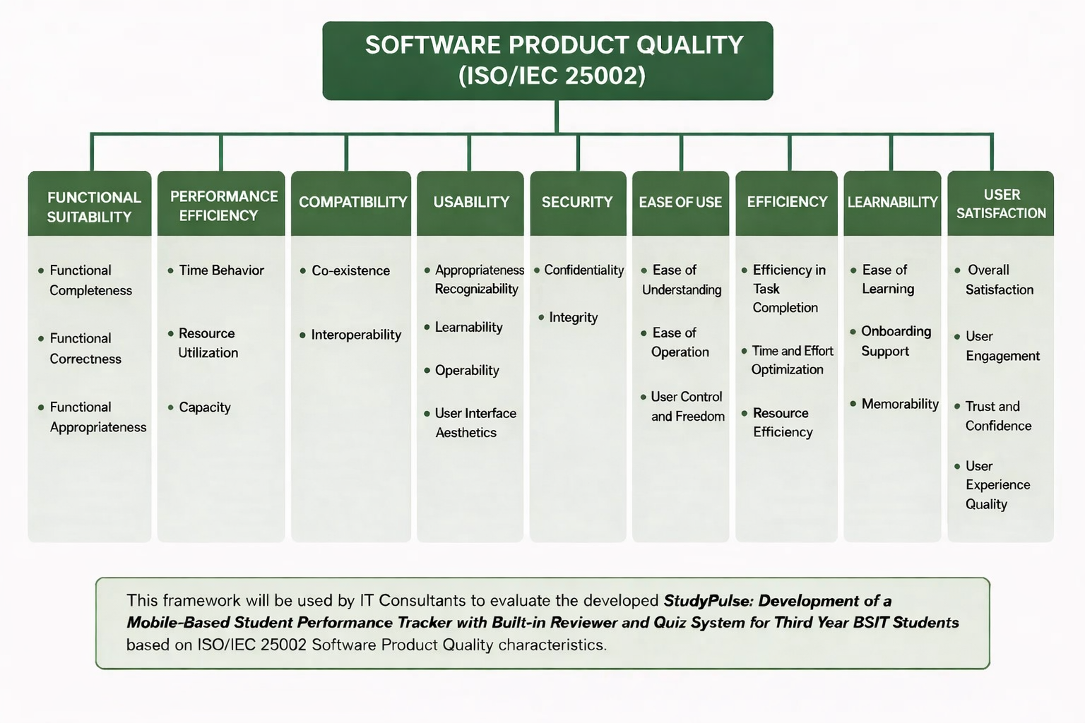
In general, the developed system in this study was assessed using the ISO/IEC 25002 Software Product Quality model as shown below.

Figure 3. ISO25002 Software Product Quality Standard

A different set of research questionnaires was provided to IT consultants and end-users. IT consultants were given a complete set of ISO/IEC 25002 Software Product Quality characteristics, specifically: functional suitability, performance efficiency, compatibility, usability, and security. These characteristics were used to evaluate the developed StudyPulse: Development of a Mobile-Based Student Performance Tracker with Built-in Reviewer and Quiz System for Third Year BSIT Students in terms of its overall system quality.
However, end-users were only given a questionnaire based on the System Usability Scale (SUS), which includes selected usability-related characteristics such as ease of use, efficiency, learnability, and user satisfaction. This was due to the technical nature of the other ISO/IEC 25002 characteristics. Other characteristics such as functional suitability, performance efficiency, compatibility, usability, and security require technical knowledge and expertise, and therefore could only be properly evaluated by IT consultants.
The following scoring guide was used to interpret the data gathered in accordance to the given ISO 25010Software Quality Standards:
Table 2.
Response Mode
Standards | Range | Interpretations | Descriptor
Functional Suitability | 4 | Very Functional | The system fully meets all required functions and performs tasks accurately and completely.
 | 3 | Function | The system meets most required functions with minor issues.
 | 2 | Slightly Functional | The system meets some required functions but has noticeable limitations.
 | 1 | Not Functional | The system fails to meet required functions and does not perform tasks properly.
Performance Efficiency | 4 | Very Efficient | The system performs tasks quickly and efficiently with optimal resource usage.
 | 3 | Efficient | The system performs well with minimal delays.
 | 2 | Slightly Efficient | The system shows some delays and moderate inefficiency.
 | 1 | Not Efficient | The system is slow and inefficient in performing tasks.
Compatibility | 4 | Very Compatible | The system works seamlessly across different devices and environments.
 | 3 | Compatible | The system works in most environments with minor issues.
 | 2 | Slightly Compatible | The system works in limited environments with noticeable issues.
 | 1 | NOt Compatible | The system does not work properly across different environments.
Usability | 4 | Very Usable | The system is very easy to use and navigate with no confusion.
 | 3 | USable | The system is generally easy to use with minor difficulties.
 | 2 | Slightly Usable | The system is somewhat difficult to use and requires effort.
 | 1 | Not Usable | The system is difficult to use and confusing.
Security | 4 | Very Secured | The system provides strong protection of data and prevents unauthorized access.
 | 3 | Secured | The system provides adequate protection with minor vulnerabilities.
 | 2 | Slightly Secured | The system has some security measures but with noticeable risks.
 | 1 | Not Secured | The system lacks security and is vulnerable to threats.
Ease of use | 4 | Very Easy | The system is extremely simple and effortless to use.
 | 3 | Easy | The system is easy to use with minimal effort.
 | 2 | Slightly Easy | The system requires some effort to use.
 | 1 | Not Easy | The system is difficult to use.
Learnability | 4 | Very easy to learn | Users can quickly learn and understand how to use the system without difficulty.
 | 3 | Easy to learn | Users can learn the system with minimal effort.
 | 2 | Slightly difficult to learn | Users need some time and effort to learn the system.
 | 1 | Difficult to learn | Users find it hard to learn and understand the system.
User Satisfaction | 4 | Very satisfied | Users are highly satisfied and pleased with the system.
 | 3 | Satisfied | Users are generally satisfied with the system.
 | 2 | Slightly satisfied | Users are somewhat satisfied but have some concerns.
 | 1 | Not satisfied | Users are dissatisfied with the system.

DATA GATHERING PROCEDURE ‎ ‎
The data gathering procedure of this study was conducted in a systematic manner to ensure the accuracy, reliability, and validity of the results. The process began with securing permission from the school administration of Nueva Ecija University of Science and Technology (NEUST) Talavera Off-Campus to conduct the study among third-year BSIT students. After approval, the researchers coordinated with instructors and students who would serve as respondents of the study. ‎
‎Following this, the researchers developed the StudyPulse mobile application using the Agile Development Model. Once the system was completed, it was introduced to the selected respondents, including IT experts, instructors, and third-year BSIT students. The respondents were given an orientation on how to use the application, including its features such as performance tracking, reviewer, quiz system, and gamification elements. ‎
‎After the orientation, the respondents were allowed to use the system for a specific period to explore its functionality and features. During this phase, students used the application to review lessons, take quizzes, and monitor their academic performance, while instructors utilized the system to manage learning materials and assessments. ‎
‎Upon completion of the testing period, data were collected using evaluation instruments. IT experts evaluated the system based on ISO 25002 software quality characteristics, including functionality, performance efficiency, compatibility, usability, and security. Meanwhile, student respondents evaluated the system using the System Usability Scale (SUS) to measure ease of use, efficiency, learnability, and overall satisfaction. ‎
‎The collected data were then compiled, organized, and analyzed using appropriate statistical tools to determine the effectiveness, usability, and performance of the StudyPulse application. The results of the evaluation served as the basis for identifying necessary improvements and for validating the overall functionality and reliability of the developed system.
DATA ANALYSIS TECHNIQUE
The data for the development stage of the StudyPulse: Development of a Mobile-Based Student Performance Tracker with Built-in Reviewer and Quiz System for Third Year BSIT Students were analyzed critically and presented in textual form, as the process primarily involved system design, feature integration, and application development. No statistical treatment was required during this phase since it focused on the construction and functionality of the mobile-based system.
On the other hand, the data gathered from the end-users, particularly the Third Year BSIT students and instructors, were analyzed statistically using the weighted mean. This was used to evaluate the usability, functionality, and effectiveness of the StudyPulse system, including its performance tracking, reviewer, and quiz features.
To specifically address Statement of the Problem 1 (SOP 1), the researchers used the weighted mean to determine the overall assessment of the respondents regarding the usability, functionality, and effectiveness of the system. The weighted mean allowed the researchers to quantify the respondents’ level of agreement with each indicator in the evaluation questionnaire and to interpret the overall performance of the system based on the computed mean scores.
Morever, the data collected during the evaluation stage from IT experts and faculty members were computed using weighted scores and weighted mean. The results were analyzed based on the different software quality criteria aligned with ISO/IEC 25002, including usability, functional suitability, reliability, and performance efficiency. This ensured that the developed system met standard software quality requirements and was suitable for academic use.
ETHICAL COSIDIRATION
The researchers ensured that the study, “StudyPulse: Development of a Mobile-Based Student Performance Tracker with Built-in Reviewer and Quiz System for Third Year BSIT Students,” was conducted in an ethical and responsible manner. All participants were treated with respect and their rights were protected throughout the research process.
Prior to participation, informed consent was obtained from all respondents. They were clearly informed about the purpose of the study, the procedures involved, and their role as participants. Participation was entirely voluntary, and respondents were given the freedom to withdraw from the study at any time without any consequences.
The researchers also ensured the confidentiality and privacy of all data gathered. Any personal information collected was kept secure and was not disclosed to any unauthorized individuals. The data were used solely for academic purposes.
Furthermore, the study followed the principle of “do no harm,” ensuring that no physical, emotional, or psychological harm was inflicted on the participants. The researchers also maintained honesty and integrity in collecting, analyzing, and presenting the data, avoiding any form of falsification or manipulation of results.
Overall, the study adhered to ethical research standards to ensure fairness, transparency, and respect for all participants involved.

REFERENCES
https://stratfordjournalpublishers.org/journals/index.php/journal-of-education/article/view/1712
https://stratfordjournalpublishers.org/journals/index.php/journal-of-education/article/view/1712
https://www.mdpi.com/2227-7102/10/3/47
https://www.mdpi.com/2227-7102/11/3/121
https://www.sciencedirect.com/science/article/pii/S0360131519301236�
https://www.sciencedirect.com/science/article/pii/S0747563215002558
https://www.sciencedirect.com/science/article/pii/S0360131517302886
https://educationaltechnologyjournal.springeropen.com/articles/10.1186/s41239-017-0069-7
https://www.sciencedirect.com/science/article/pii/S0360131525001836 https://www.mdpi.com/2076-3417/14/19/9105. https://www.ijlter.org/index.php/ijlter/article/view/11850
https://www.sciencedirect.com/science/article/pii/S0360131516301397
‎[https://link.springer.com/article/10.1186/s41239-017-0069-7]
‎[https://link.springer.com/article/10.1186/s40064-016-2971-1]
‎[https://www.inettutor.com/source-code/mobile-based-board-exam-review-of-related-literature/]
‎[https://www.tandfonline.com/doi/full/10.1080/09639284.2022.2041057]
‎[https://link.springer.com/article/10.1007/s11423-026-10586-2]
https://link.springer.com/article/10.1186/s41239-017-0069-7?utm_sourcem

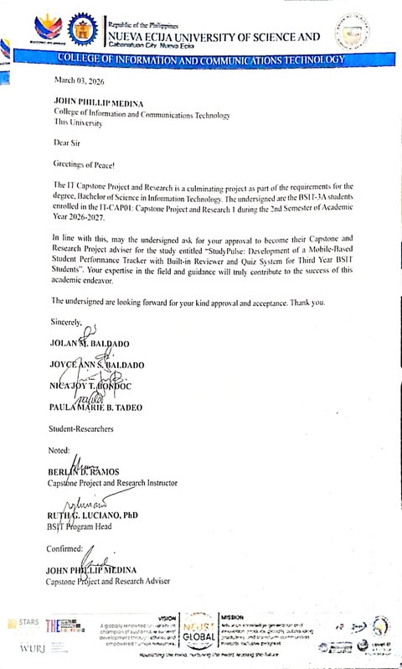
APPENDICES
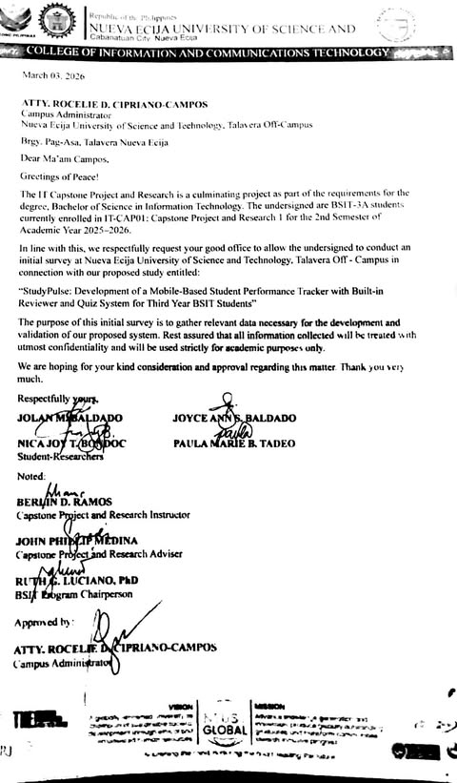
APPENDIX A Letter of Request


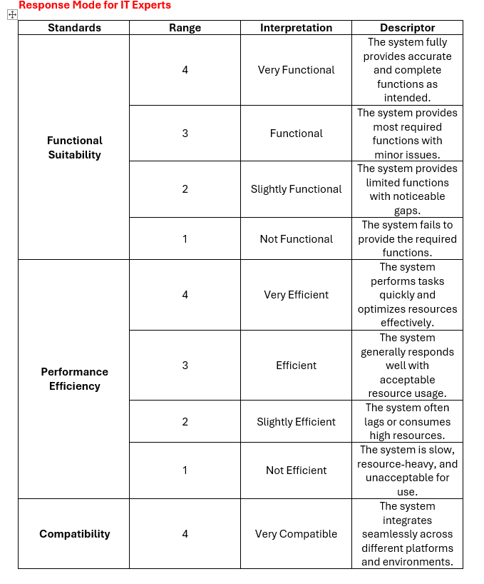
Appendix B IT Experts Survey Questionnaire
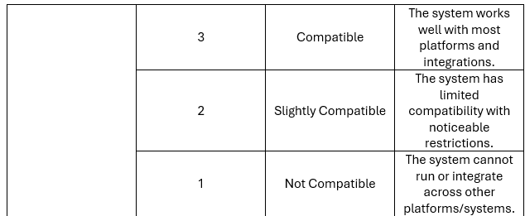

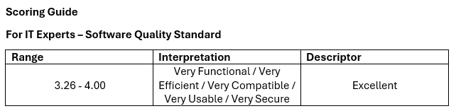
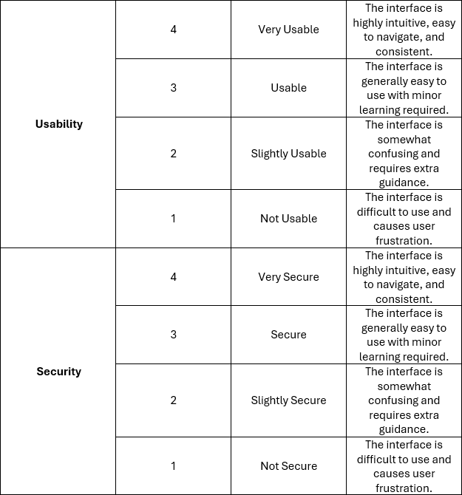
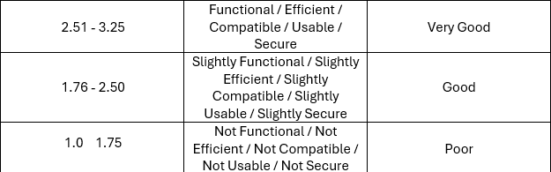

Response Mode for End Users
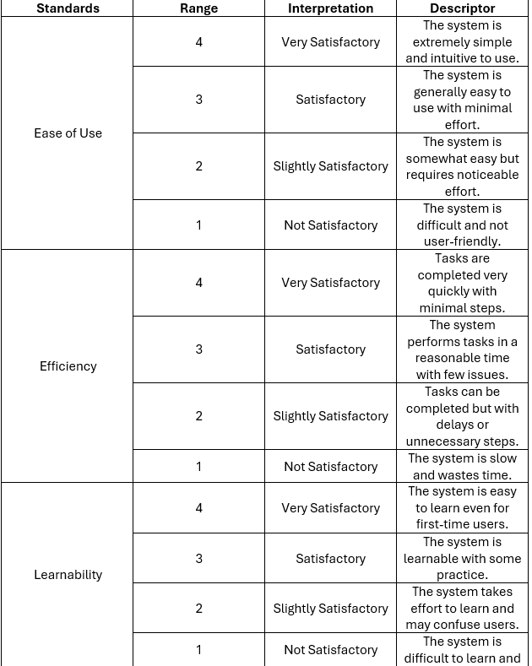
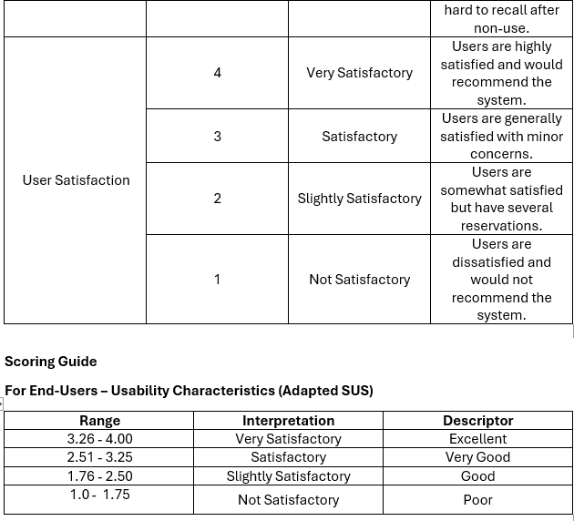

APPENDIX C End User Survey Questionnaire
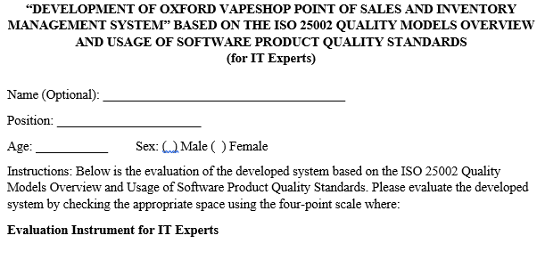

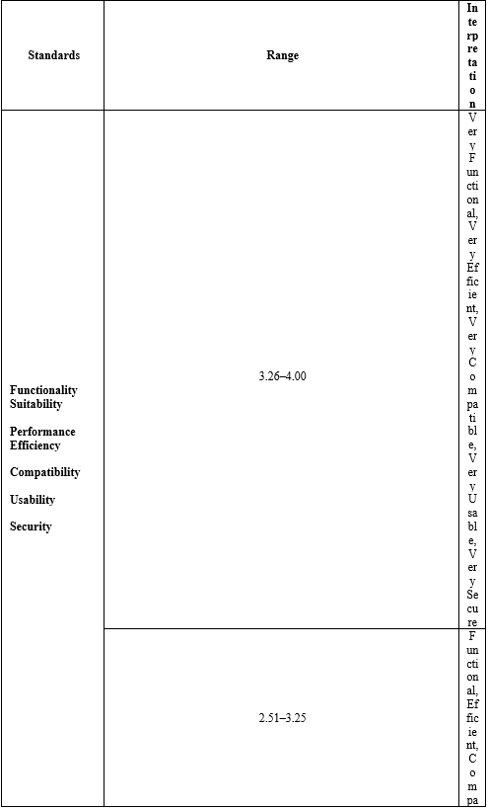

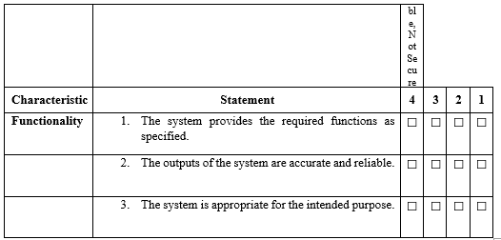
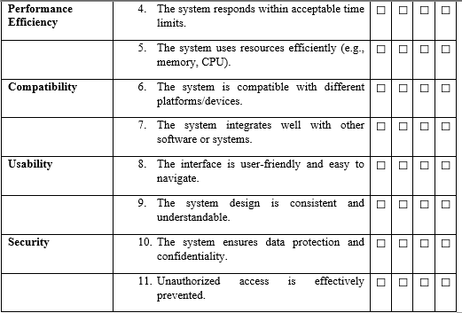

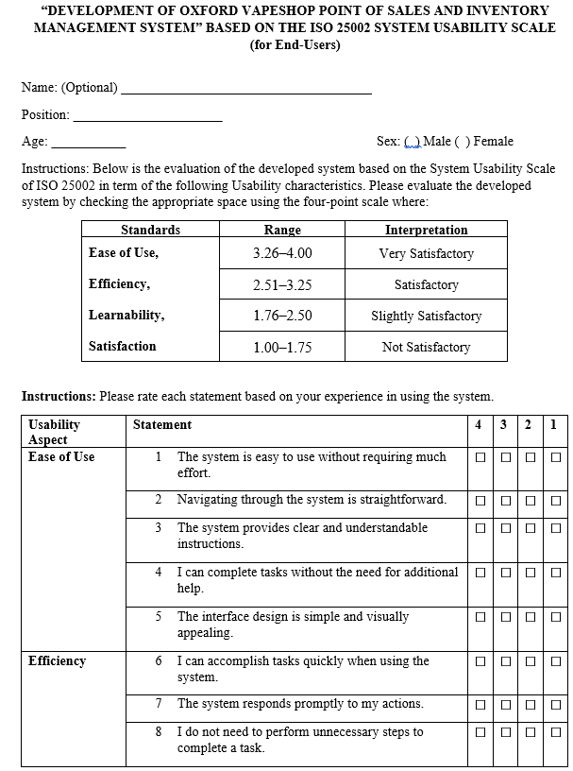
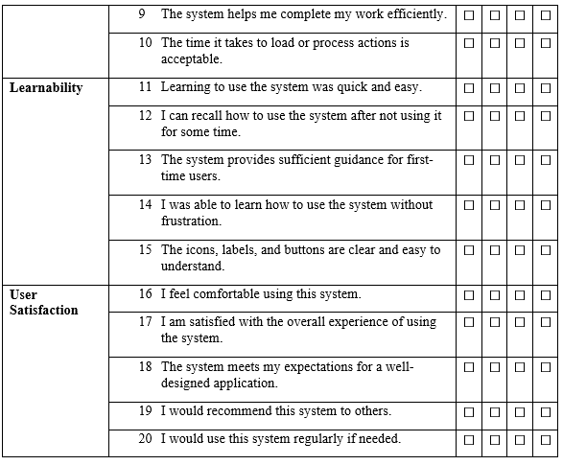

CURRICULUM VITAE
PERSONAL INFORMATION
Name : Baldado, Jolan M.
Address : Baloc, Sto.Domingo Nueva Ecija
Contact Number: 09304057415
Email: baldadojolan@gmail.com
Birthday: February 06, 2005
Birthplace: Baloc Sto.Domingo Nueva Ecija
Sex : Female
Civil Status : Single
Height : 4'11
Weight: 55
Citizenship: Filipino
Religion: Iglesia Ni Cristo
EDUCATIONAL BACKGROUND
Senior High School: Sto. Domingo National Trade School
Baloc Sto. Domingo Nueva Ecija
Humanity and Social Sciences
2022-2023
Junior High School: Sto. Domingo National Trade School
Baloc Sto. Domingo Nueva Ecija
2020-2021
Elementary : Baloc Sto. Domingo Elementary School
Baloc Sto. Domingo Neuva Ecija
2016-2017


PERSONAL INFORMATION

Name : Joyce Ann S. Baldado
Address : Bertese, Quezon, Nueva Ecija
Contact Number: 09628249925
Email: joyceannbaldado97@gmail.com
Birthday: August 17 2005
Birthplace : San Carlos City Province Hospital
Sex: Female
Civil Status: Single
Height; 5’1
Weight : 50
Citizenship: Filipino
Religion: Iglesia Ni Cristo
EDUCATIONAL BACKGROUND
Senior High School: Eduardo L. Joson Memorial High School
Bertese, Quezon Nueva Ecija
Humanity and Social Sciences
2022-2023
Junior High School: Eduardo L. Joson Memorial High School
Bertese, Quezon, Nueva Ecija
2020-2021
Elementary : Tomas Joson Elementary School
Ilog Baliwag Quezon Neuva Ecija
2016-2017


PERSONAL INFORMATION

Name: Bondoc, Nica Joy T.
Address: Baloc, Sto.Domingo Nueva Ecija
Contact Number: 09514310928
Email : bondocn672@gmail.com
Birthday : September 10, 2005
Birthplace: Baloc Sto.Domingo Nueva Ecija
Sex: Female
Civil Status: Single
Height : 5’4
Weight : 67
Citizenship: Filipino
Religion: Catholic

EDUCATIONAL BACKGROUND
Senior High School: Sto. Domingo National Trade School
Baloc Sto. Domingo Nueva Ecija
Humanity and Social Sciences
2022-2023
Junior High School: Sto. Domingo National Trade School
Baloc Sto. Domingo Nueva Ecija
2020-2021
Elementary: Felix T. Pascual Elementary School
Bulihan Baloc Sto. Domingo Neuva Ecija
2016-2017


PERSONAL INFORMATION

Name: Tadeo, Paula Marie B.
Address: Bacal 1, Talavera Nueva Ecija
Contact Number: 09245813351
Email: paulamarietadeo9@gmail.com
Birthday: December 06, 2004
Birthplace: City of Manila
Sex: Female
Civil Status : Single
Height : 5’5
Weight : 70
Citizenship : Filipino
Religion : Catholic

EDUCATIONAL BACKGROUND
Senior High School: Sto. Domingo National Trade School
Baloc Sto. Domingo Nueva Ecija
Accountancy, Business, and Management 2022-2023
Junior High School: Sto. Domingo National Trade Schoool
Baloc Sto. Domingo Nueva Ecija
2020-2021
Elementary : Bakal 1 Elementary School
Bacal 1 Talavera Neuva Ecija
2016-2017

